DBMS Project

Topic: - Shopping Mall

PROBLEM STATEMENT: Design a system to organise the work of Shopping Mall. Through the aforementioned management system, we strive to achieve the following objectives:
- Organising registration of new brand.
- Supervising the regulation of operations concerning sales, cleaning, security, technical issues and other matters concerning a shopping mall.
- Maintaining Customer database.
- Registration of new goods’ information.
- Enabling the administrator to retrieve information about the products, employees and customers of the shopping mall.
- Staff management.
- Retrieving data concerning the overall coordination and functioning of the mall.
1 Assumptions
1.1 Managers
This entity contains MID (primary key), Name is a composite attribute comprising of First_name and Last_name , Salary ,Responsibilities ,DOB and Age is a derived attribute.
1.2 Cleaning
Cleaning contains EID(primary key), E_name,Floor, Salary and MID as foreign key from Managers entity.
1.3 Technical
Technical holds details about the technical department. Details such as E_ID, E_name ,salary ,Specification and M_ID which is the foreign key from Managers table.
1.4 Security
Security entity holds the E_ID(primary key),E_name,Salary and M_ID as foreign key from entity Managers.
1.5 Shops
It contains SID(primary key), Sown_name, floor,brand, rent and M_ID as foreign key from entity managers.
1.6 Sales_person
Shopping entity holds SP_ID(primary key) ,Salary, sp_name, S_ID as foreign key from entity Shops.
1.7 Products
Products entity holds PR_ID(primary key) ,Category, Quantity, SP,CP and S_ID as foreign key from entity Shops.
1.8 Customers
Customers entity holds C_ID(primary key) ,Phone_no which is a multivalued attribute, c_name, mail_id .
1.9 Buys
It’s a relationsip between Customers and Products. It holds special attributes Date,Quantity ,C_ID as foreign key from entity Customers, Pr_ID as foreign key from entity Products. Pr_ID, C_ID and Date collectively forms the primary key.
2.0 Payments
Payments entity holds TRANS_ID(primary key) ,Amount, , SP,CP and S_ID as foreign key from entity Shops.

2 Entity Relationship Diagram
The below figure shows the Entity Relation diagram of Shopping Mall Management System.

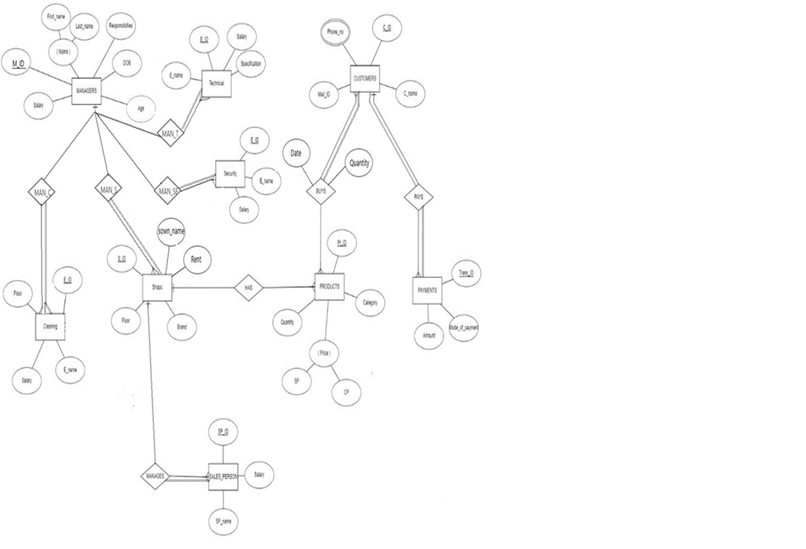
3 Relational Database Schema

A relational database schema helps you to understand and organize the structure of a database. It is helpful when we design a new database or existing database is modified to incorporate new functionality.

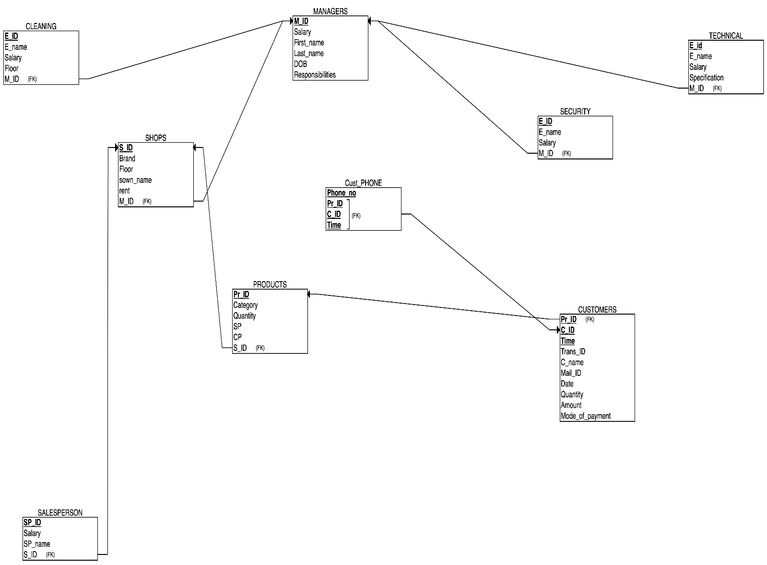

4 Dependencies and Normalization
4.1 Managers
There exists two functional dependencies {M_ID → F_Name,L_Name,responsibilities,DOB,Salary} , {Responsibilities -> Salary}. The table is in 2 NF.
After Normalization:
Table 1. Managers {M_ID -> F_Name,L_Name,responsibilities,DOB}
Table 2. Department {Responsibilities -> Salary}
The tables are in BCNF.

4.2 Cleaning
The functional dependencies are {E_ID → EName,Floor,Salary,M_ID}.
There exists full functional dependency. Hence table is in BCNF.

4.3 Technical
The functional dependencies are {E_ID → EName,Specification,Salary,M_ID}, {Specification -> Salary}. The table is in 2NF.
After Normalization:
Table 1. Technical {E_ID → EName,Specification,M_ID}
Table 2. Specification {Specification -> Salary}.
The tables are in BCNF

4.4 Security
The functional dependencies are {E_ID → EName,Salary,M_ID}.
There exists full functional dependency. Hence table is in BCNF.

4.5 Shops
The functional dependencies are {S_ID → Sown_name,Rent,floor,brand}.
The table is in BCNF.

4.6 Salesperson
The functional dependencies are {Sp_ID → name,S_ID,salary}.
The Table is in BCNF.

4.7 Products
The functional dependencies are {Pr_ID → Category,SP,CP,Quantity} .
The table is in BCNF.

4.8 Customers
The functional dependencies are {C_ID → Mail_Id,C_name,Phone} , {C_ID,Pr_ID,Time → Mail_Id,C_name,Phone ,Quantity,TransactionID,mode_of_payment,Amount} , {TransactionID,Pr_ID → Mail_Id,C_name,Phone, Quantity,C_ID,Time,mode_of_payment,Amount } , {TransactionID→ Mail_Id,C_name,Phone, Quantity,C_ID,Time,mode_of_payment,Amount }
The table is in 1NF. There exist Partial Dependencies.
After Normalization:
Table 1. Customer { C_ID → Mail_Id,C_name,Phone }
Table 2. Payment {TransactionID,Pr_ID → Quantity }
Table 3 Details {TransactionID → Mail_Id,C_name,Phone, Amount,C_ID,Time,mode_of_payment}

